M3 Assignment 02: Flights Data

This Tableau file contains information on all U.S. airline flights from 2010 and 2011. Create a Tableau worksheet to answer each of the following questions:

To submit, upload your word doc with answers onto Canvas > Class-Work-2 assignment

**FILE to use: Flights_data.twbx**

1. A quick viz of flights over time shows a drop of more than 300,000 flights from 2010 to 2011:



From your experience, you know that flight activity did not drop so significantly between 2010 and 2011. Why does this viz seem to indicate otherwise? **Investigate flights over time in more detail to determine why these yearly numbers show such a large drop.**

Hint: Use the ‘Number of Records’ and ‘Flight Date’ variables to investigate. Note your finding below and paste the jpg of the viz. below it.

According to the visual below, there is a significant drop in February of 2010 and 2011. This explains the large drop in the graphs.

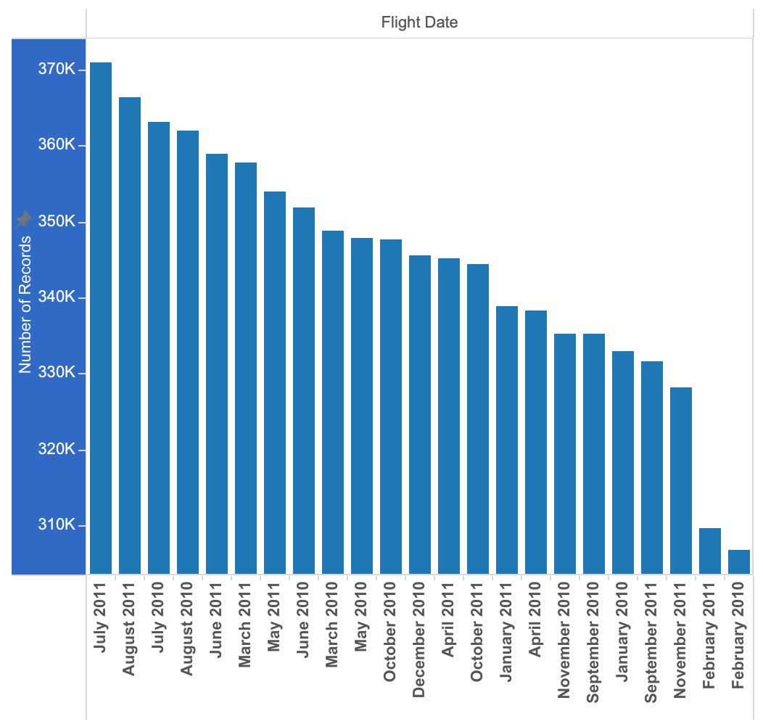

1. You want to know who operates the most flights and therefore probably dominate market share. **Is there one airline that operated more flights than any other single airline for each week in this dataset?**

Hint: Use the ‘Number of Records’ and ‘Flight Date’ variables to investigate. Note your finding below and paste the jpg of the viz. below it.

The airline with the most operated flights compared to any other airline in the visual was Southwest.

